**REAL ESTATE DATA**



**INTRODUCTION**

**Real estate data is a collection of information about properties and their surrounding areas. It can include details like the age of a house, its price, and its location (longitude and latitude). This data also often includes information about the neighborhood, such as the distance to the nearest metro station and the number of convenience stores nearby. Analyzing this data can help people make informed decisions about buying or selling property.**

OBJECTIVE**Sum of House Age and Sum of Distance to the Nearest MRT station by Number of convenience Stores.**

* **Sum of Latitude by Longitude and House price of unit area.**

DATA EXPLANATION:

* **TRANSACTION DATE:** It is refer to the specific date when the legal ownership of a house officially transfers from the seller to the buyer, marking the completion of the sale and signifying that the buyer now owns the property.
* HOUSE AGE: **The number of years or days since the house was built.**
* **Distance to Nearest MRT station: The distance from the house to the nearest Mass Rapid Transit station.**
* Number of convenience stores: **It shows how many stores are available in particular area.**
* **Latitude:** **Latitude specifies the North-South position of the house on the earth surface.**
* Longitude: **Longitude specifies the East-West position of the house.**
* House price per Unit area: **The price of the house per square unit of area.**

**VISUALIZATION-EXPLANATION**

**CLUSTER CHART**

**"This cluster chart shows the relationship between the number of convenience stores near a house and the total age of houses in that area. Each cluster on the x-axis represents a different number of convenience stores, from zero to ten. The height of each bar, shown on the y-axis, represents the sum of the ages of the houses for that specific number of nearby convenience stores. For example, we can see that when there are five convenience stores nearby, the total age of the houses is the highest, reaching over 1200. We can also compare the total house age for areas with zero convenience stores to areas with one or two, and so on."**

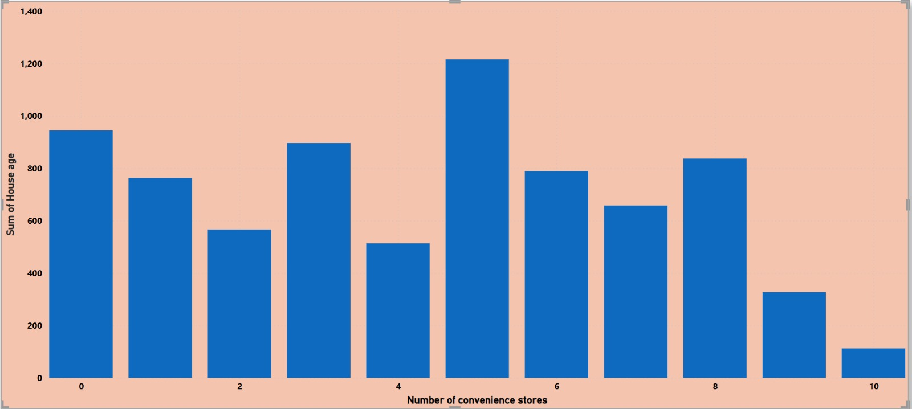

**Donut chart**

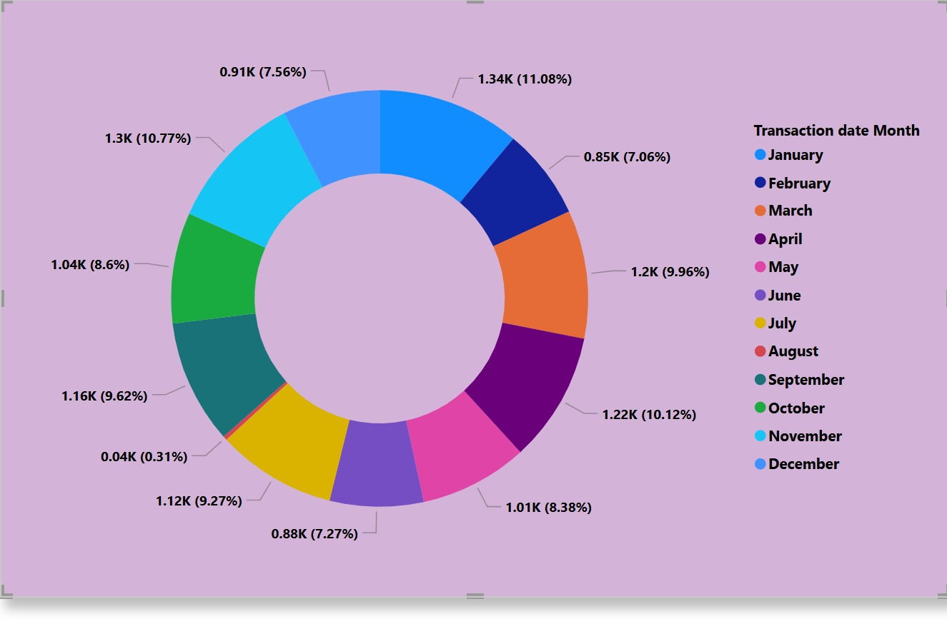

***shows a donut chart that displays how much of something happened in each month of a year. Think of it like a pie chart, but with a hole in the middle.***

***Each slice of the donut represents a month, and the size of the slice shows how important or big that month was. The bigger the slice, the more happened in that month.***

***The chart also tells you the exact number for each month (like 1.34K for February) and what percentage of the total that number is (like 11.08% for February). The "K" probably means thousands.***

***The colors help you easily see which month is which, and there's a list on the side that tells you what each color means.***

***Basically, this chart helps you quickly see which months were the busiest or most important, and how they compare to each other. For example, it looks like February and June were big months, while December was very slow.***

***Multirow card:***

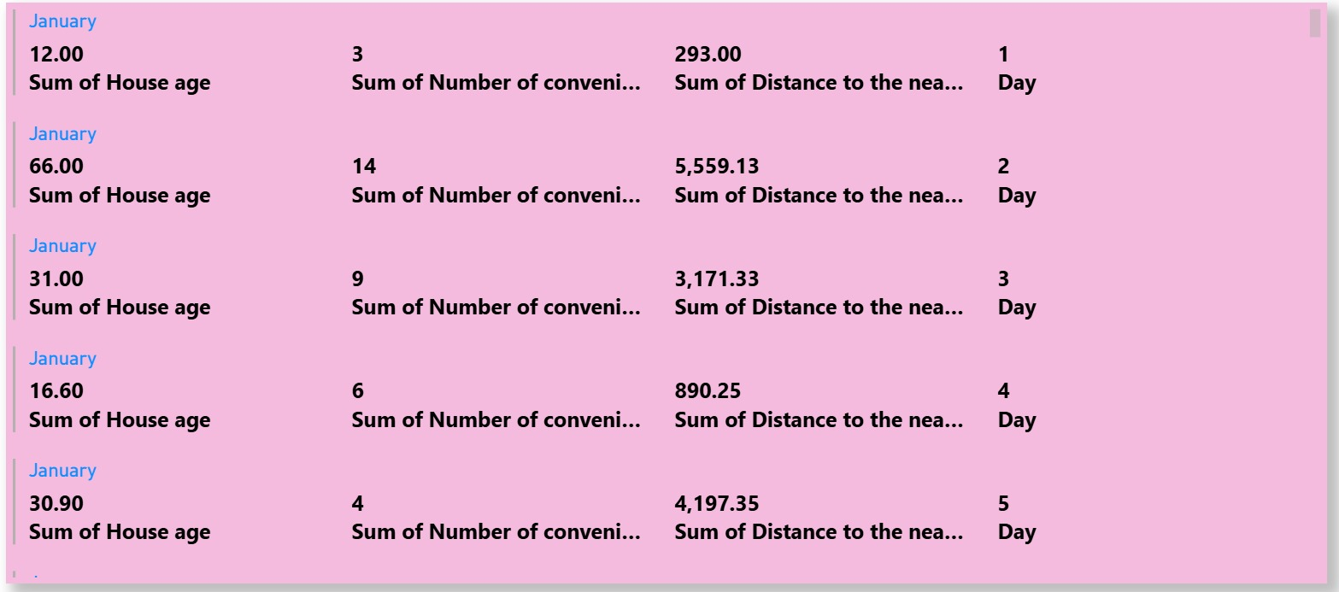

This table provides a snapshot of house-related data for the first five days of January. By analyzing the variations in the sums of house age, number of convenience stores, and distance to the metro, one can potentially gain insights into the characteristics of the housing market or area being studied.

Slicer:

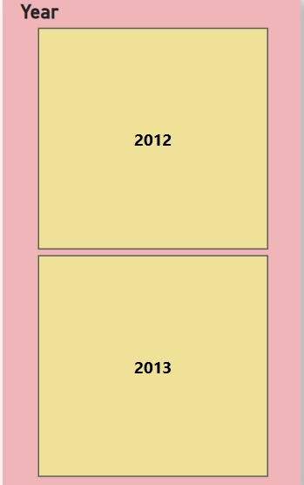

This picture shows a simple table with two boxes, one for the year 2012 and one for 2013. It's probably used to compare information from those two years.

Map:

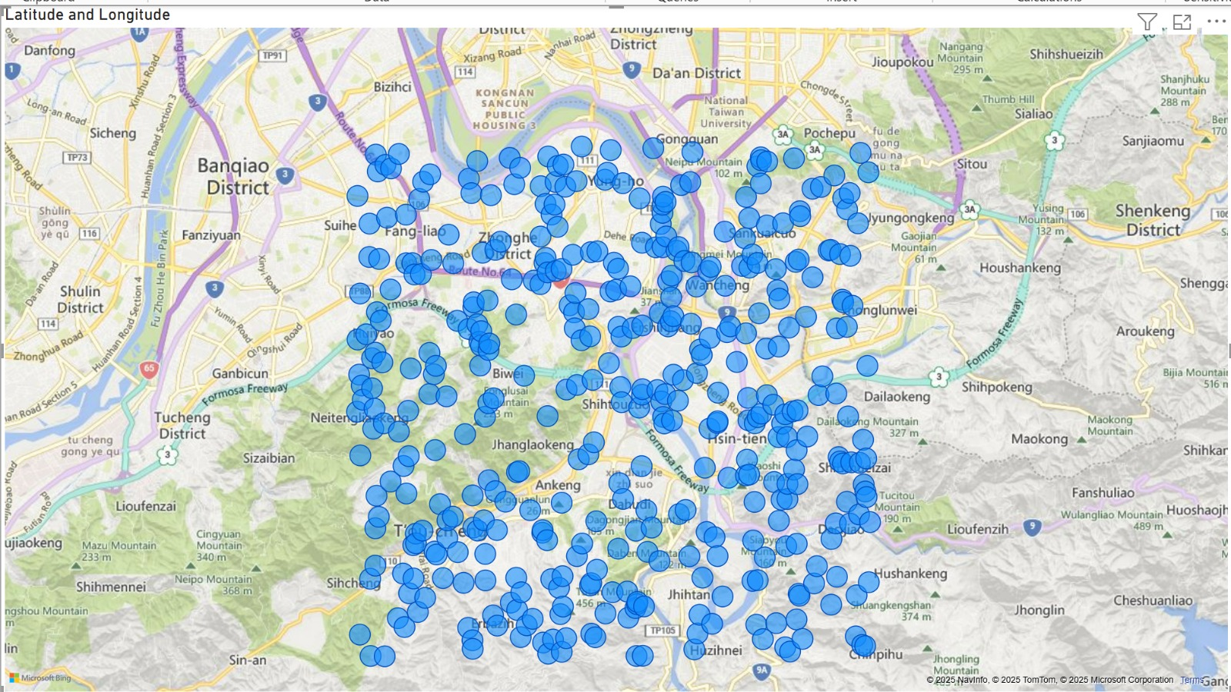

This picture shows a map of Taiwan with a bunch of blue dots scattered across it. It looks like the dots are more crowded in some areas than others. This probably means something is happening more in those crowded areas, like maybe more people live there, or more stores are located there, or more of a certain type of event is happening there. The map helps us see where these things are happening in Taiwan.

**CONCLUSION:**

**Finally the analysis show that areas with more convenience stores and better MRT access tend to have higher property demand. Older houses are often farther from MRT stations , while never developments are closer to key transport hubs . Additionally , property prices vary by location , with prime areas having higher unit prices due to better infrastructure and amenities . These insights help in making informed real estate investment decision .**